BAPTIST LUI MING CHOI SECONDARY SCHOOL
EUROPE CLUB

DÊ PERSEÔ FABULÂ
(THE STORY OF PERSEUS)

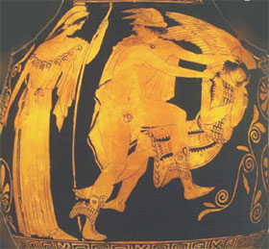
From the online version at: http://www.mythfolklore.net/fabulaefaciles/index.htm
With interlinear translation and illustrations from Greek vase paintings and later European art added
Note that long vowels are marked in this text by a circumflex (e.g. â) instead of a macron (e.g. ā)
DÊ PERSEÔ FABULÂ

1.Haec nârrantur â poêtîs dê Perseô. Perseus fîlius erat Iovis,

These-things are-told by poets about Perseus Perseus son was Jove’s
mâximî deôrum; avus êius Acrisius appellâbâtur. Acrisius
greatest of-gods grandfather his Acrisius was-called Acrisius
volêbat Perseum nepôtem suum necâre; nam propter ôrâculum
was-wanting Perseus grandson his-own to-kill for because-of oracle
puerum timêbat. Comprehendit igitur Perseum adhûc infantem,
boy was-fearing seized therefore Perseus still infant
et cum mâtre in arcâ lîgneâ inclûsit. Tum arcam ipsam in mare
and with mother in chest wooden enclosed then chest itself into sea
coniêcit. Danaê, Perseî mâter, mâgnopere territa est;
threw Danae Perseus’s mother greatly frightened was
tempestâs enim mâgna mare turbâbat. Perseus autem in sinû
storm for great sea was-disturbing Perseus however in lap
mâtris dormiêbat.
of-mother was-sleeping
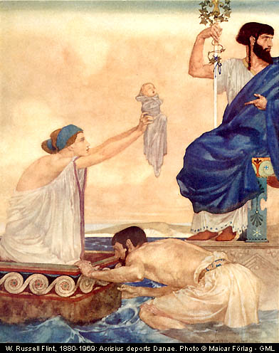
2.Iuppiter tamen haec omnia vîdit, et fîlium suum servâre
Jupiter however these-things all saw and son his-own to-save
cônstituit. Tranquillum igitur fêcit mare, et arcam ad însulam
decided calm therefore made sea and chest to island
Serîphum perdûxit. Hûius însulae Polydectês tum rêx erat.
Seriphus brought this island’s Polydectes then king was
Postquam arca ad lîtus appulsa est, Danaê in harênâ quiêtem
after chest to shore pushed was Danae in sand rest
capiêbat. Post breve tempus â piscâtôre quôdam reperta est, et
was-taking after short time by fisherman a-certain found was and
ad domum rêgis Polydectis adducta est. Ille mâtrem et puerum
to home of-king Polydectes brought was he mother and boy
benîgnê excêpit, et iîs sêdem tûtam in fînibus suîs
kindly received and to-them place-to-stay safe in territories his-own
dedit. Danaê hôc dônum libenter accêpit, et prô tantô beneficiô
gave Danae this gift willingly accepted and for such-great kindness
rêgî grâtiâs êgit.
to-king thanks gave
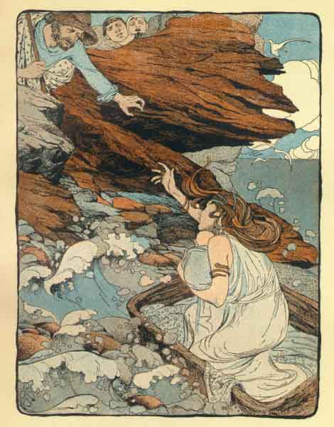
3. Perseus igitur multôs annôs ibi habitâbat, et cum mâtre
Perseus therefore many years there continued-living and with mother
suâ vîtam beâtam agêbat. At Polydectês Danaên mâgnopere
his-own life happy continued-leading but Polydectes Danae greatly
amâbat, atque eam in mâtrimônium dûcere volêbat. Hôc tamen
was-loving and her into marriage to-lead was-wanting this however
cônsilium Perseô minimê grâtum erat. Polydectês igitur Perseum
plan to-Perseus very-little pleasing was Polydectes therefore Perseus
dîmittere cônstituit. Tum iuvenem ad sê vocâvit et haec
send-away decided then youth to himself called and these-things
dîxit: "Turpe est hanc îgnâvam vîtam agere; iam dûdum tû
said disgraceful is this idle life to-lead now you
adulêscêns es. Quô ûsque hîc manêbis? Tempus est arma
teenager are when till here you-will-remain time it-is arms
capere et virtûtem praestâre. Hinc abî, et caput
to-take and courage to-display from-here go-away and head
Medûsae mihi refer."
of-Medusa for-me bring-back
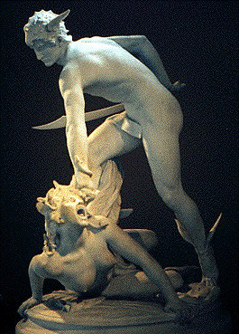
4.Perseus ubi haec audîvit, ex însulâ discessit, et postquam ad
Perseus when these-things heard out-of island departed and after to
continentem vênit, Medûsam quaesîvit. Diû frûstrâ
mainland came Medusa looked-for for-long-time in-vain
quaerêbat; namque nâtûram locî îgnôrâbat. Tandem Apollô et
was searching as nature of-place was-not-knowing at-last Apollo and
Minerva viam dêmônstrâvêrunt. Prîmum ad Graeâs, sorôrês
Minerva way showed first to Graeas sisters
Medûsae, pervênit. Ab hîs tâlâria et galeam magicam
of-Medusa reached from these winged-sandals and helmet magic
accêpit. Apollô autem et Minerva falcem et speculum
received Apollo also and Minerva curved-knife and mirror
dedêrunt. Tum postquam tâlâria pedibus induit, in âera
gave then after winged-sandals feet-to put-on into air
ascendit. Diû per âera volâbat; tandem tamen ad eum locum
rose for-long-time through air was-flying at-last however to that place
vênit ubi Medûsa cum cêterîs Gorgonibus habitâbat. Gorgonês
he-came where Medusa with other Gorgons was-living Gorgons
autem mônstra erant speciê horribilî; capita enim eârum
moreover monsters were appearance-with horrible heads for of-them
anguibus omnînô contêcta erant. Manûs etiam ex aere factae
with-snakes altogether covered were hands also out-of bronze made
erant.
were

5. Rês difficillima erat caput Gorgonis abscîdere; êius enim
Thing very difficult was head Gorgon’s to-cut-off of-her for
cônspectû homines in saxum vertêbantur. Propter hanc
by-sight men into stone used-to-be-turned because-of this
causam Minerva speculum Perseô dederat. Ille igitur
reason Minerva mirror to-Pereus had-given he therefore
tergum vertit, et in speculum înspiciêbat; hôc modô ad
back turned and in mirror began-looking this by-method to
locum vênit ubi Medûsa dormiêbat. Tum falce suâ caput
place came where Medusa was-sleeping then by-curved-knife his head
êius ûnô îctû abscîdit. Cêterae Gorgonês statim ê
of-her one by-blow cut off other Gorgons at-once from
somnô excitâtae sunt, et ubi rem vîdêrunt, îrâ
sleep wakened were and when thing saw anger-by
commôtae sunt. Arma rapuêrunt, et Perseum occîdere
moved were arms they-seized and Perseus to-kill
volêbant. Ille autem dum fugit, galeam magicam induit; et ubi
were-wanting he but while fled helmet magic put-on and when
hôc fêcit, statim ê cônspectû eârum êvâsit.
this he-did at-once from sight their he-escaped

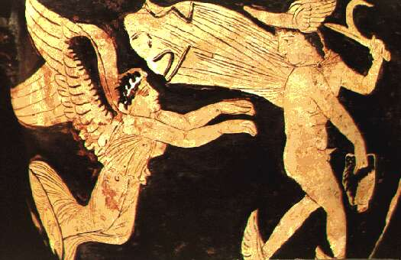
6. Post haec Perseus in fînîs Aethiopum vênit. Ibi Cêpheus
after these-things Perseus in territory of-Ethiopians went there Cepheus
quîdam illô tempore rêgnâbat. Hîc Neptûnum, maris deum, ôlim
a-certain at-that time was-ruling he Neptune of-sea god once
offenderat; Neptûnus autem mônstrum saevissimum mîserat.
had-offended Neptune then monster most-cruel had sent
Hôc cottîdiê ê marî veniêbat et hominês dêvorâbat. Ob
this daily out-of sea used-to-come and people used-to-eat for
hanc causam pavor animôs omnium occupâverat. Cêpheus igitur
this reason fear minds of-all had seized Cepheus therefore
ôrâculum deî Hammônis cônsuluit, atque â deô iûssus est fîliam
oracle of-god Hammon consulted and by god ordered was daughter
mônstrô trâdere. Êius autem fîlia, nomine Andromeda, virgô
to-monster to-hand-over his moreover daughter by-name Andromeda girl
fôrmôsissima erat. Cêpheus ubi haec audîvit, mâgnum dolôrem
most-beautiful was Cepheus when these-things heard great sorrow
percêpit. Volêbat tamen cîvîs suôs ê tantô perîculô
felt he-wanted however citizens his from such-great danger
extrahere, atque ob eam causam imperâta Hammônis facere
to-take-away and for this reason orders Hammon's to do
cônstituit.
decided
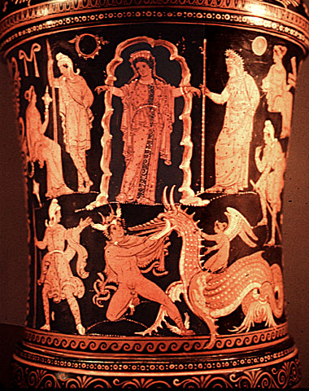
7. Tum rêx diem certam dîxit et omnia parâvit. Ubi ea diês
then king day a-certain said and all-things prepared when that day
vênit,Andromeda ad lîtus dêducta est, et in cônspectû omnium
came Andromeda to shore taken-down was and in sight of-all
ad rûpem adligâta est. Omnês fâtum êius dêplôrâbant, nec
to rock tied was all fate of-her were-sad-about and-not
lacrimâs tenêbant. At subitô, dum mônstrum exspectant,
tears were-holding back but suddenly while monster they-are-waiting-for
Perseus accurrit; et ubi lacrimâs vîdit, causam dolôris quaerit.
Perseus rushes-up and when tears has-seen reason of-sorrow asks
Illî rem tôtam expônunt et puellam dêmônstrant. Dum haec
they thing whole explain and girl show while these-things
geruntur, fremitus terribilis audîtur; simul mônstrum
are happening roaring terrible is-heard at-same-time monster
horribilî specie procul cônspicitur. Êius cônspectus timôrem
with-horrible appearance far-away is-seen his appearance fear
mâximum omnibus iniêcit. Mônstrum mâgnâ celeritâte ad lîtus
greatest in-all instilled monster with-great speed to shore
contendit, iamque ad locum appropinquâbat ubi puella stâbat.
rushed and-now to place was-approaching where girl was-standing
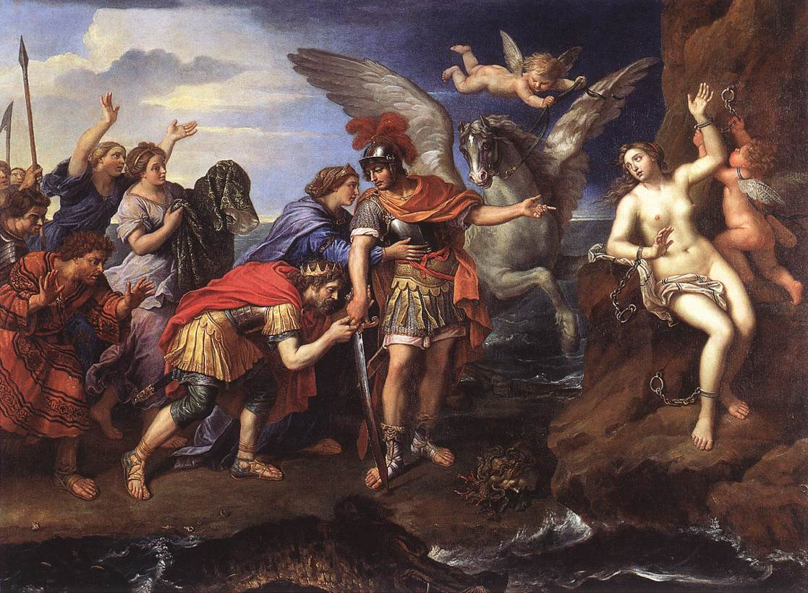
8. At Perseus ubi haec vîdit, gladium suum êdûxit, et
but Perseus when these-things saw sword his took-out and
postquam tâlâria induit, in âera sublâtus est. Tum dêsuper in
after winged-sandals put-on in air lifted-up was. Then from-above on
mônstrum impetum subitô fêcit, et gladiô suô collum êius
monster attack suddenly made and sword-with his his neck of-it
graviter vulnerâvit. Mônstrum ubi sênsit vulnus, fremitum
seriously wounded monster when felt wound roaring
horribilem êdidit, et sine morâ tôtum corpus in aquam mersit.
horrible gave out and without delay whole body in water sank
Perseus dum circum lîtus volat, reditum êius exspectâbat. Mare
Perseus while around shore flies return of-it was-waiting-for sea
autem intereâ undique sanguine înficitur. Post breve tempus
but meanwhile everywhere with-blood is-stained after short time
bêlua rûrsus caput sustulit; mox tamen â Perseô îctû graviôre
beast again head raised soon however by Perseus with-blow heavier
vulnerâta est. Tum iterum sê in undâs mersit, neque posteâ
wounded is then again itself into waves sank and-not afterwards
vîsa est.
seen was

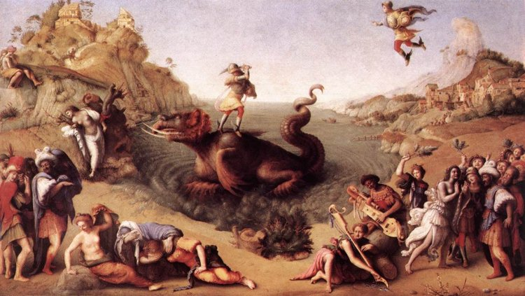
9. Perseus, postquam ad lîtus dêscendit, prîmum tâlâria exuit;
Perseus after to shore came down first sandals took-off
tum ad rûpem vênit ubi Andromeda vincta erat. Ea autem
then to rock came where Andromeda tied was she but
omnem spem salûtis dêposuerat, et ubi Perseus adiit, terrôre
all hope of-safety had-abandoned and when Perseus arrived by-fear
paene exanimâta erat. Ille vîncula statim solvit, et puellam
almost died had he chains at-once unfastened and girl
patrî reddidit. Cêpheus ob hanc rem mâximô gaudiô adfectus
to-father returned Cepheus for this thing with-greatest joy affected
est. Meritam grâtiam prô tantô beneficiô Perseô rettulit;
was deserved thanks for such-great good-deed to-Perseus returned
praetereâ Andromedam ipsam eî in mâtrimônium dedit. Ille
besides andromeda herself to-him in marriage he gave he
libenter hôc dônum accêpit et puellam dûxit. Paucôs annôs cum
gladly this gift accepted and girl married few years with
uxôre suâ in eâ regiône habitâbat, et in mâgnô honôre erat apud
wife his in that region continued-living and in great honour was among
omnîs Aethiopês. Mâgnopere tamen mâtrem suam rûrsus vidêre
all Ethiopians greatly however mother his again to-see
cupiêbat. Tandem igitur cum uxôre suâ ê rêgnô Cêpheî
was-wanting finally therefore with wife his from kingdom of-Cepheus
discessit.
departed
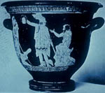

10. Postquam Perseus ad însulam nâvem appulit, sê ad locum
after Perseus to island ship brought himself to place
contulit ubi mâter ôlim habitâverat, sed domum invênit vacuam
took where mother once had lived but house found empty
et omnînô dêsertam. Trîs diês per tôtam însulam mâtrem
and completely deserted three days through whole island mother
quaerêbat; tandem quartô diê ad templum Diânae pervênit. Hûc
continued-seeking finally on-fourth day at temple of-Diana arrived to-here
Danaê refûgerat, quod Polydectem timêbat. Perseus ubi
Danae had-fled because Polydectes was-afraid-of Perseus when
haec côgnôvit, îrâ mâgnâ commôtus est; ad rêgiam
these-things learned by-anger great moved was to palace
Polydectis sine morâ contendit, et ubi eô vênit, statim in
of-Polydectes without delay hurried and when there came at-once into
âtrium inrûpit. Polydectês mâgnô timôre adfectus est et
hall burst Polydectes by-great fear affected was and
fugere volêbat. Dum tamen ille fugit, Perseus caput Medûsae
to run away was-wanting whilst however he fled Perseus head of-Medusa
mônstrâvit; ille autem simul atque hôc vîdit, in saxum versus
showed he and soon as this saw into stone turned
est.
was

11. Post haec Perseus cum uxôre suâ ad urbem Acrisî rediit.
after these-things Perseus with wife his to town of-Acrisius returned
Ille autem ubi Perseum vîdit, mâgnô terrôre adfectus est; nam
he but when Perseus saw with-great fear affected was for
propter ôrâculum istud nepôtem suum adhûc timêbat. In
because-of oracle that grandson his still was-fearing into
Thessaliam igitur ad urbem Lârîsam statim refûgit, frûstrâ
Thessaly therefore to city Larissa at-once fled in-vain
tamen; neque enim fâtum suum vîtâvit. Post paucôs annôs rêx
however not for fate his avoided after a-few years king
Lârîsae lûdôs mâgnôs fêcit; nûntiôs in omnîs partîs dîmîserat et
of-Larisa games great made messengers in all parts had sent and
diem êdîxerat. Multî ex omnibus urbibus Graeciae ad lûdôs
day had-announced many from alll cities of-Greece for games
convênêrunt. Ipse Perseus inter aliôs certâmen discôrum iniit.
Met-together himself Perseus among others contest of-discus entered
At dum discum conicit, avum suum câsû occîdit; Acrisius
and while discus threw grandfather his own by-accident killed Acrisius
enim inter spectâtôrês êius certâminis forte stâbat.
for among spectators of-that contest by-chance was-standing

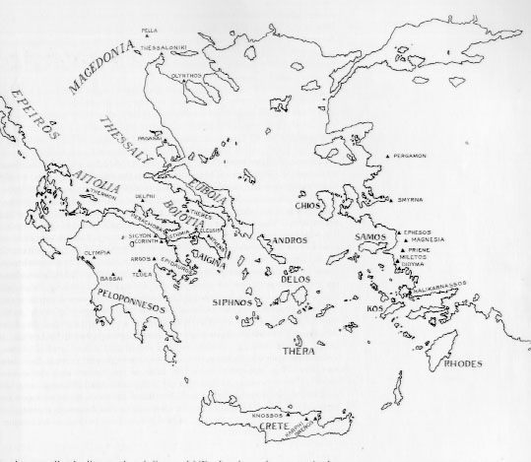
Ancient Greece (Acrisius was king of Argos in the Peloponnese)

An oracle is a prophecy or forecast about the future made with the help of some special power.
Literally, `is’ but with a past participle it makes a passive past tense.
The Latin is literally `was doing an idle life’.
The two words iam dûdum together can be translated by just one English word.
Literal translation: `are’
ubi
Latin sometimes switches from past tense to present to make a story about the past seem more real. When the present is used in this was it is called the historic present. How many verbs in the historic present can you find in this paragraph?

