**Sagittarius -人馬座The Archer

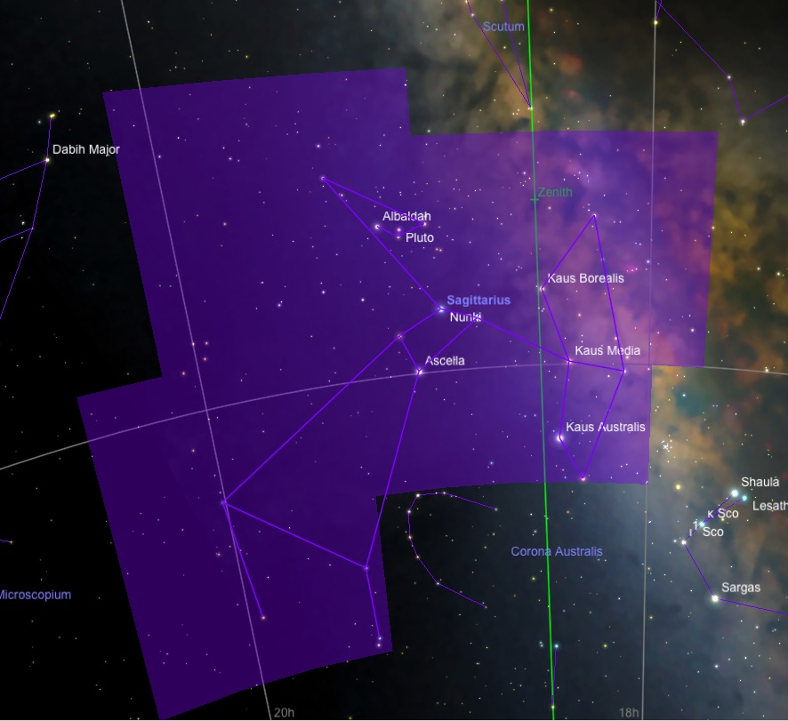

The central Milky Way銀河系 runs through the western region of Sagittarius. This area contains the most abundant and wide-ranging collection of deep sky objects in the sky.

History and Mythology

The constellation Sagittarius was recorded by Ptolemy 托勒密 in the second century AD. Sagittarius is believed to have been recorded as far back as 1000 BCE in the ancient Babylonian astronomical compendium.

The Greeks believed the constellation represented both a centaur and the archer Crotus. Crotus is described as a great marksman and a friend of the muses. While enjoying their music, Crotus expressed his joy with loud clapping or stomping, thus creating the origin story for musical rhythm. The muses were said to be so fond of his celebratory attentions that they demanded that Crotus be placed in the heavens.

Notable Stars

The bright stars in Sagittarius form a figure that resembles a teapot more than an archer.

Clusters, Nebulae, and Galaxies

The center of our galaxy lies in the direction of Sagittarius. This area of the heavens is densely populated with star clusters and nebulae, many of which can be seen with the naked eye. The Sagittarius Star Cloud, M 24, is the densest region in the Milky Way. On a clear, dark night this area is a spectacular sight in binoculars.

* Delta Sagittarii - 箕宿二 (人馬座δ) Kaus Media
At magnitude 2.72, Kaus Media ranks fourth brightest in the constellation Sagittarius, the Archer. The star lies in the middle of Sagittarius's bow, and also marks the eastern end of the arrow that points into the heart of the Milky Way.

Properties
Kaus Media is a class K3 III giant star with a temperature of 4300 K. Its distance of 305 light years implies a luminosity of 1180 suns, and a radius 62 times solar. Including dimming by interstellar dust, the star may actually be up to 30% brighter and 15% larger. With a relatively high mass of five suns, Kaus Media is mostly likely fusing helium into carbon in its core.

*Epsilon Sagittarii -箕宿三（人馬座ε) Kaus Australis
At magnitude 1.85, Epsilon Sagittarii is the second brightest star in Sagittarius. It forms the southern end of the Archer's "bow", and also marks the base of the spout of the "Teapot" asterism.

Properties
Epsilon Sagittarii has traditionally been classified as a B9.5 III blue-white giant, with a temperature of 9200 K. Its distance of 145 light years implies a luminosity of 375 suns, much brighter than its main sequence (hydrogen-fusing) counterparts, and has a mass nearly four times solar. It is seven times larger than the Sun.

Kaus Australis is clearly in a more advanced evolutionary state, probably having a cooling, shrinking helium core that is preparing to fuse into carbon and oxygen.

* Sigma Sagittarii - Nunki
At magnitude 2.02, Sigma Sagitarii is the second brightest star in Sagittarius, the Archer, and appears in the handle of the constellation's "teapot" asterism.

Because it is close to the ecliptic, Nunki can be occulted by the Moon and very rarely by planets. Nunki is the brightest star that can be occulted by an exterior planet.

Properties and Evolution
Nunki is a brilliant class B2.5 V main-sequence star, dimmed by its distance of 225 light years. With a surface temperature of 20,000 K, bluish Nunki is one of the hotter bright stars, and radiates much of its light in the invisible ultraviolet. Visually, it shines with 630 times the Sun's luminosity, but when we take the ultraviolet into account, the star's luminosity is actually 3300 suns. To be so bright, Nunki must also be fairly large, and has a diameter about five times the Sun's.

Typical of hot, young stars, Nunki is a fast spinner, rotating with a speed of over 200 km/sec - 100 times that of our Sun. Like the Sun, Nunki is powered by the fusion of hydrogen into helium in its deep core. But its mass - seven times the Sun's - is so high, and its internal fusion rate so great, that it cannot "burn" this way for very long (50 million years at most). The star will ultimately turn into a white dwarf roughly as massive as the Sun.

* Pluto冥王星

Until 2006, Pluto was counted as the ninth planet行星 in the solar system. It is much smaller than any of the other planets, and has a highly elliptical and inclined orbit unlike the others'. Today, Pluto is no longer considered to be a planet, but is rather the first of a new category of objects called dwarf planets矮行星.

History and Mythology
Pluto was discovered in 1930 by the American astronomer Clyde Tombaugh.
The discovery of Pluto made headlines across the globe. Pluto, the Roman name for the god of the underworld, seemed appropriate for such a dark and distant planet.

Ancient Roman mythology has Pluto as the Lord of Death, burials, and mourning for the dead; he is identified with the Greek god Hades. Pluto was often pictured bestowing the blessings of new life from a cornucopia.

Declassification and Dwarf Planets
In 1978, astronomer James Christy discovered that Pluto has a moon of its own, named Charon after the ferryman of the dead.

As astronomers began to discover other objects in the outer solar system beyond Neptune - some larger than Pluto - it became clear that Pluto did not deserve major planet status. In 2006, the International Astronomical Union officially de-classified Pluto as a planet, and gave it the minor planet designation, (134340) Pluto. The 2006 IAU resolution specified three conditions for an object to be considered a planet:

1. It must be in orbit around the Sun, not another planet (or moon).
2. It must be massive enough to have pulled itself into the shape of a sphere by its own gravitational force.
3. It must be gravitationally dominant enough to have "cleared the neighborhood" around its orbit of other bodies of comparable size.

A large body which meets the first two criteria for a planet, but has not cleared its neighborhood is classified as a "dwarf planet". Along with Pluto, the IAU currently recognizes four other dwarf planets in our Solar System: Ceres, Eris, Haumea, and Makemake.

Orbit
Pluto orbits the Sun once every 248 years. Pluto's orbit is quite eccentric, and takes Pluto from about 30 A.U. to about 48 A.U. from the Sun. For a few years during every orbit, Pluto is actually closer to the Sun than Neptune. Pluto's orbit also highly inclined to the Ecliptic (by about 17 degrees). This high inclination helps Pluto avoid a collision with Neptune, since when their orbits cross, Pluto is far above the plane of the solar system.

Pluto orbits in a zone known as the Kuiper Belt. This region lies beyond the orbit of Neptune, and is believed to contain hundreds, if not thousands, of bodies similar to Pluto. Pluto is also the prototype and namesake of a group of objects called Plutinos. The Plutinos orbit in the same region of space and, like Pluto, have a 2:3 orbital resonance with Neptune (completing 2 orbits for every 3 orbits of Neptune). In addition to Pluto, the other largest Plutinos include (90482) Orcus, (28978) Ixion, (38083) Rhadamanthus, and (38628) Huya.

Size and Composition
Pluto's diameter is about 2300 km - only about two-thirds the diameter of the Earth's Moon. Pluto's density is also low (about 2 grams per cubic centimeter) so it contains only about one-sixth the mass of the Moon. If you weighed 100 pounds on Earth, you would only weigh 8 pounds on Pluto.

The Moons of Pluto
Pluto has five known moons, including Charon (discovered in 1978). Charon is about half the size of Pluto and even less dense, leading to speculation that they formed at different times or in different locations. Charon orbits Pluto closely, with a period of 6.39 days. Both objects are tidally locked, always showing the same face to each other.

No spacecraft have yet visited Pluto, but NASA's New Horizons mission is currently en route, and will fly by Pluto and its moons in 2015.

