Hercules -武仙座The Hero

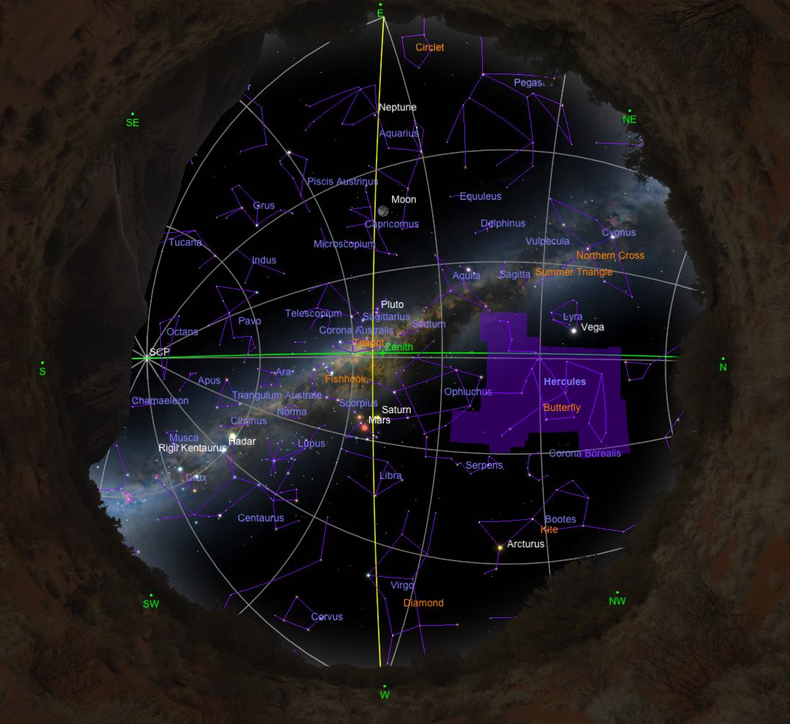

Hercules appears as a kneeling man, located between Draco天龍座 and Ophiuchus蛇夫座. His foot is on Draco's head, as if ready to slay the dragon. Lyra天琴座 is to the east, and Corona Borealis北冕座is to the west.

History and Mythology

Hercules was known for his tremendous strength. He was the son of a mortal mother, Alcmene, and the god Zeus. Hera, the jealous wife of Zeus, plotted to kill the baby Hercules. She sent serpents to kill the child, but Hercules strangled the creatures. As he grew, Hercules gained great strength, until he became the strongest man in the world.

Hera vowed to make Hercules' life one of suffering. Under her spell, Hercules killed his own children. To atone for these acts, Hercules was the servant of the king of Mycenae, Eurysteus. To win his freedom, he had to perform twelve great labors. His accomplishments were compared with the Sun's annual journey through the twelve signs of the zodiac. Hercules was poisoned and upon his death was taken to join the gods on Mount Olympus where he was placed in the heavens.

Notable Stars

The four upper stars in Hercules form a figure known as the "keystone". The main figure of the constellation resembles the outline of a butterfly.

Clusters

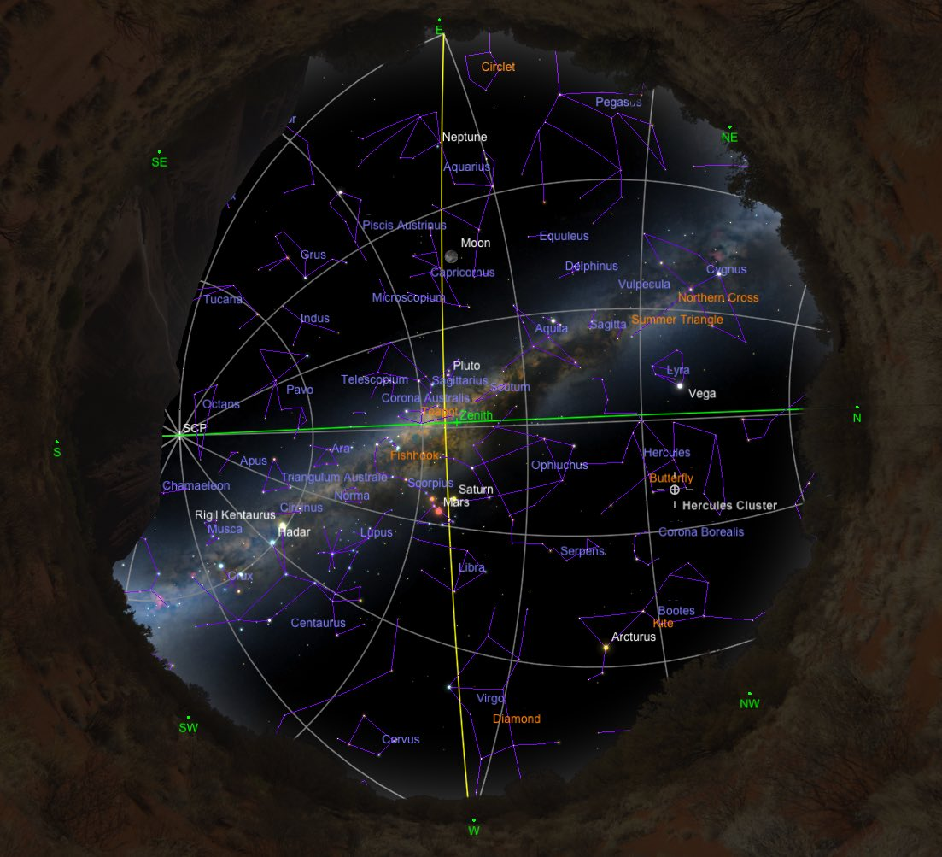

The globular cluster球狀星團 M 13 is one of the most magnificent objects in the northern sky. At magnitude 5, it contains about 300,000 stars, and it is about 24,000 light-years away. It is visible with the naked eye, and in an 8-inch telescope M 13 resolves into thousands of stars. Famously, M 13 is the object to which the Arecibo radio telescope sent a message indicating the existence of humanity in 1974.

