** Centaurus

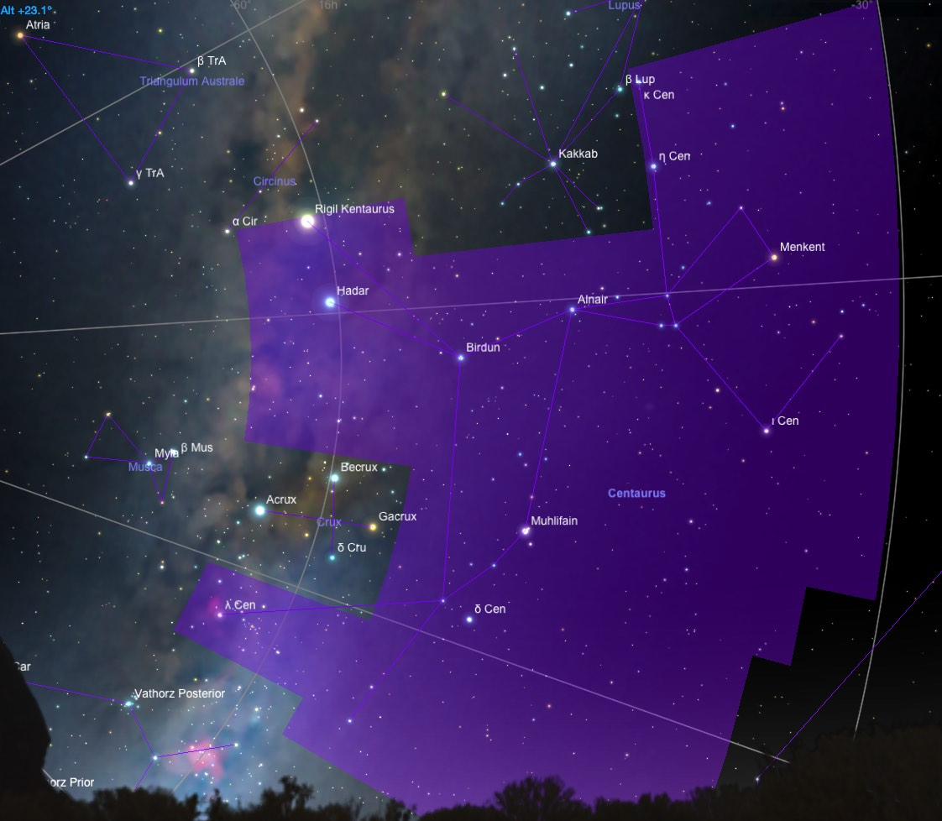

Centaurus - The Centaur
Centaurus is a prominent southern constellation. It is one of the major constellations along the southern Milky Way. For southern observers, it signifies the coming of fall. Crux, the Southern Cross, lies on the southern boundary of Centaurus. The constellations Centaurus and Sagittarius both represent centaurs.

History and Mythology

The figure of Centaurus can be traced back to the Babylonians. They associated this creature with their Sun god.

In Greek and Roman mythology, the constellation Centaurus has always been associated with a centaur. The centaur is a mythical creature that was half man, half horse. According to the Roman poet Ovid, the constellation represents Chiron, the wise centaur who mentored many Greek heroes including Achilles, Jason, Theseus, and Heracles. One of Chiron's accomplishments was to create the constellations. Chiron placed the stars into groups allowing people to read the patterns in the sky. They could now predict the seasons by following the stars. Chiron created a southern constellation, Centaurus, to honor himself.

However, most authorities consider Sagittarius to be the wise Chiron, while Centaurus represents one of the more uncivilized members of the species.

Notable Stars

Centaurus contains Alpha Centauri, the third brightest star in the sky and the closest star system to our own. Alpha Centauri is 4.3 light-years away. It is also known as Rigel Kentaurus, the "foot of the centaur" (not to be confused with Rigel in Orion). It is a triple star system with yellow components of magnitude 0.0 and 1.2. The two brighter components have an 80-year orbital period, over which their apparent separation varies from 2 to 22 arcseconds. The brighter component is a remarkably sunlike star; its companion has about half the Sun's luminosity.

The third member of the system is Proxima Centauri, a red dwarf in a long-period orbit around Alpha Centauri. It is currently the closest of the three, about a tenth of a light-year closer to us, and appears at 13th magnitude, about two degrees south of the brighter pair. It has 0.0008 of the Sun's luminosity.

Beta Centauri is a bluish star of magnitude 0.61, and is the tenth brightest star in the sky. Also called Hadar, which comes from the Arabic word for "ground", this star is 335 light-years away and therefore bright because it is truly luminous.

Clusters, Nebulae, and Galaxies

The largest and richest globular cluster in the sky is Omega Centauri. It can be seen with the naked eye as a fuzzy ball as large as the full moon. In a small telescope it is a stunning sight, in which thousands of individual stars can be seen.

In areas of Centaurus not obstructed by the Milky Way, there is a good selection of galaxies, some of which are southern members of the Coma-Virgo galaxy cluster. Two are of special interest to amateur observers. Centaurus A (NGC 5128) is a peculiar edge-on galaxy with a large dust lane extending across the nucleus. At seventh magnitude, it is the fifth-brightest star in the sky, and is also known to be a radio source. Its strange shape is the result of a collision between a larger elliptical galaxy and a smaller spiral which it is devouring. NGC 4945 is a bright edge-on spiral visible in any medium-size telescope.

Also notable is the region of nebulosity surrounding the star Lambda Centauri. This region, dubbed the Running Chicken nebula, is IC 2948. The associated star cluster is IC 2944.

Located near IC 2948 is the Pearl Cluster, NGC 3766, a very dense fifth magnitude open cluster that lies at a distance of 5500 light-years. NGC 5286 is an eighth magnitude globular cluster located 4 degrees SW of Zeta Centauri. NGC 3918 is a bright eighth magnitude planetary nebula, often called the Blue Planetary due to its beautiful rich blue color.

* Alpha1 Centauri, Alpha2 Centauri, Proxima Centauri - Rigil Kentaurus
Alpha Centauri, the third brightest star in the sky, is a yellowish-white star of magnitude -0.27 which lies at the foot of the Centaur. At only 4.3 light years distant, it is also the closest star system to our own. Alpha Centauri is in fact a triple star system consisting of two rather close, Sun-like stars (α Cen A and B), accompanied by a very distant, faint red dwarf (α Cen C or Proxima Centauri).

History and Mythology

Alpha Centauri has the traditional name Rigil Kentaurus (often shortened to Rigil Kent), meaning "Foot of the Centaur" in Arabic. The first magnitude star Hadar (Beta Centauri) lies about 4 degrees west of Alpha Centauri. In the southern hemisphere, Alpha and Beta Centauri are known as "The Pointers", as both stars directly point towards the constellation Crux, the Southern Cross.

Alpha Centauri was well known in ancient Egypt. Temples were built to celebrate the time when the star rose with the Sun at the autumn equinox. The ancient Chinese designated the Alpha and Beta Centauri as "Nan Men", which means the "The South Gate of the Sky".

Alpha Centauri A and B

Alpha Centauri is a double star. Its two bright components, α Cen A and B, orbit one another with a period of 79.9 years, during which time their angular separation varies from 2 to 22". Their separation was at maximum in 1976, will be at minimum in 2016.

Proxima Centauri

The red dwarf C component is often called Proxima Centauri because it is about a seventh of a light year closer to us than the two brighter components (4.22 vs 4.36 ly). It is therefore the nearest individual star to our Solar System.

Proxima Centauri is a red dwarf star of spectral class M5 Ve. It is extremely faint and small; its luminosity is merely 0.0008 that of the Sun. Its mass is only one tenth the Sun's, and it is smaller in size than the planet Saturn. Like many red dwarfs, Proxima is a "flare star" that can roughly double in brightness sporadically from hour to hour. Its designated variable star name is V645 Centauri.

Possible Planets

Since Alpha Centauri A is very similar to our own Sun, many speculate whether it might possess planets that harbor life. Alpha Centauri A and B are 1.7 - 1.8 times richer in "metals", i.e. elements heavier than hydrogen, than our own Sun. Most stars known to have planets have similarly high metallicities. Recent simulation results conclude that multiple planets could have formed in close orbits around both heavy-element-rich stars.

In a binary system, a planet must orbit closer to its "home" star than about 1/5th of the closest approach of the other star, or its orbit will be disrupted by the gravitational pull of that second star. Both α Cen A and B could have one or two "rocky" planets in orbital zones where liquid water is possible. Both stars are therefore prime targets in the search for Earth-like planets around nearby stars.

If our own Sun were viewed from the Alpha Centauri system, it would appear as a bright yellow star of magnitude +0.46 in the constellation Cassiopeia, almost as bright as Capella appears in our sky.

